**COMSATS University Islamabad, Abbottabad Campus**

**Department of Computer Science**

**Traffic Violation Control System**

**CSC392 Object-Oriented Software Engineering**

Submitted on: <19th Dec-2022>

Group Members:

Name:

1. **Usama Sajjad (SP21-BSE-049) [Leader]**
2. Shah Rafi Alam Khattak (SP21-BSE-060)
3. Muhammad Shahan (SP21-BSE-081)
4. Zakeen Khan (SP21-BSE-083)
5. Shams ul Arifeen (SP21-BSE-076)
6. Hikmat Ullah(SP21-BSE-097)

ContentCHAPTER 1 PROJECT PROPOSAL 4

Introduction 4

Vision and Business Case 4

Use-Case Model 4

Supplementary Specification 4

Glossary 5

CHAPTER 2 USE CASES 8

Use Case Diagram 8

Brief Level Use Cases 8

Shah Rafi Alam khattak(SP21-BSE-060) 8

Zakeen khan (SP21-BSE-083) 9

Use Case: View Institute 9

Muhammad Shahan(SP21-BSE-081) 9

Usama Sajjad (SP21-BSE-049) 9

Himat Ullah (SP21-BSE-097) 10

Shams ul Arifeen(SP21-BSE-076) 10

Fully Dressed Use Cases 11

Shah Rafi Alam khattak(SP21-BSE-060) 8

Zakeen khan (SP21-BSE-083) 9

Use Case: View Institute 9

Muhammad Shahan(SP21-BSE-081) 9

Usama Sajjad (SP21-BSE-049) 9

Himat Ullah (SP21-BSE-097) 10

Shams ul Arifeen(SP21-BSE-076) 10

CHAPTER 3 System Sequence Diagram 27

Shah Rafi Alam khattak(SP21-BSE-060) 8

Zakeen khan (SP21-BSE-083) 9

Use Case: View Institute 9

Muhammad Shahan(SP21-BSE-081) 9

Usama Sajjad (SP21-BSE-049) 9

Himat Ullah (SP21-BSE-097) 10

Shams ul Arifeen(SP21-BSE-076) 10

Chapter 4 Domain Model 35

Chapter 5 Operation Contracts 35

Usama Sajjad(SP21-BSE-049) 35

CHAPTER 6 Logical Architecture 37

# CHAPTER 1 PROJECT PROPOSAL

## Introduction

In modern society, quick mobility is one of the most basic needs. Therefore, people can use different transportation facilities such as automotive vehicles, subways, and bicycles. However, among all these transportation facilities, automotive vehicles are still the most adopted due to their comfort and practicality. In this way, assuming continuous population growth, the number of vehicles in large cities will increase as well, but much faster than transportation infrastructure; consequently, traffic congestion will become a pressing issue. It creates several negative concerns for the environment and society such as an increase in number of traffic accidents, economic impacts, and high levels of greenhouse emissions.

This project contains all traffic rules which have to be obeyed on the road while driving. This will contain a whole network of authorities that deal with the rules of traffic violations. This will make a way of conversation between the traffic management authorities and the people whom the others violate the traffic rules daily. This project would have a proper system for charging the one who does not obey the rules. People will be able to report others that are violating the rules. In this way, you never know who reported you for the violation. This will also add up to the management of the traffic which is hard these days due to overpopulation.

This project will include a feature that will allow the user to record the violation with the help of his smartphone and report the driver. After which the assigned warden on duty would check if it is a proper violation or not. Then after analyzing the video warden would send a fine (Challan) to the driver which he has to pay or his license would be terminated. The recorder of the video will also get a cut from the payment of the challan. There is one more condition if the violation is not valid and the recorder of the video was just playing then the recorder account would get a warning not to do it again or we will not give him back the security that he had paid to register in our app.

## Vision and Business Case

The vision of this project is that we want to make a change in the discipline of the underdeveloped countries. Where there is a violation of rules at its peak. Where people do not have any fear of violating the rules or the traffic warden. This project will help to overcome the violations and will help to attain discipline in those countries. This will help to align people to obey the traffic rules. The vision also includes making it easy for traffic management authorities to locate the areas where there is a high rate of violations. Traffic management systems in underdeveloped countries are very irresponsible and lazy to a high rate of violations and people not taking them seriously. This vision will help to ease the responsibilities of that department and will help them to control the violations. This vision will give the responsibility of law enforcement to every citizen of the area. Every person who has a mobile phone can use this vision to help the authorities make action against the reported person and make him pay the fine. In this way, people will think twice before committing any violation. This will also increase the rate of efficiency because the manual system is too slow also this will require fewer people to implement which will save both time and money.

When we talk about the business case of this project, this would also help the traffic management system to take the maximum fines and create a handsome revenue. This will also help the secondary user to generate an amount by reporting the violations. This is a very useful project for the government for tax generation in the form of fines.

## Use-Case Model

The functional requirements of a Traffic Violation Management System are:

1. Register
2. Deposited Security
3. Record Violation
4. Report Violation
5. Check Rewards
6. Withdraw Rewards
7. View Violation
8. Reject Complain

9. Disable Citizen

10. Verify warden

11. View Challan

12. Issues Challan

## Supplementary Specification

These are some non-functional requirement in this project. User (Principal) validation will be done during login to insure that the user is valid and that the user only has access to his or her permission data. General users will only have access through the user interface. Moreover, Video capturing of the citizen, challan (fine) submission, the data base storage, Challan form history, challan records etc.

## Glossary

## Absolute Speed Limit Violation

if the speed limit reads 55 miles per hour (MPH), then you will be punished with absolute violations

Basic Speeding Violation

if the speed limit is 65 MPH but the roads are icy, 55 MPH would still be considered a dangerous speed—even though you’re driving below the speed limit. Thus, a basic speeding violation might prove valid if the speed you’re going puts you or others in danger due to weather and/or other driving conditions

Dash Cam

A dash cam is a video camera, capable of recording audio and video footage, usually mounted on the dashboard of police cars. Recent laws have allowed the public to request the footage collected in traffic stops, should you want to contest a charge.

Appeal

If you lose your traffic court case, you have the option of writing an appeal to a higher court petitioning to reverse or change the decisions made against you. However, filing an appeal does not guarantee that the higher court will agree to reevaluate the case.

Contest

To contest is to formally oppose or argue against someone or something by taking legal action. For example, you might wish to go to court to contest a parking ticket you feel was administered unjustly.

Traffic Violation

You incur a traffic violation when you ignore or break the traffic laws in your state. Some examples of traffic violations include reckless driving, speeding, texting and driving, driving under the influence, driving without a license, and running red lights

## Risk List & Risk Management Plan

# Risk identification: classification and identification of potential road safety risks

1. Risk analysis and assessment: determination of the risk’s likelihood identified during the risk identification stage as well as their consequences. To achieve this goal, the statistical data of past years as well as previous experience are widely used.
2. Risk treatment: choice of risk management methods. The main risk management methods include risk minimization, risk acceptance, risk transfer, and risk rejection.
3. Permanent control over risks: risk monitoring, timely adequate response to changes in the system, and the assessment of the risk management effectiveness

|  |  |  |  |
| --- | --- | --- | --- |
| **S.no** | **Risk** | **Risk consequences** | **Way of Influence** |
| 1. | Violation of traffic rules by the driver/pedestrian | The danger of an accident  Decreased road safety | Availability of automatic photo-videorecording of traffic violations |
| 2. | Age/driving experience of the driver/pedestrian | The danger of an accident | implementation of an an-learning system for drivers with the most frequent accidents |
| 3. | The degree of alcohol or drug intoxication of the driver/pedestrian | The danger of an accident | Alcohol and drug control |

# CHAPTER 2 USE CASES

## Use Case Diagram

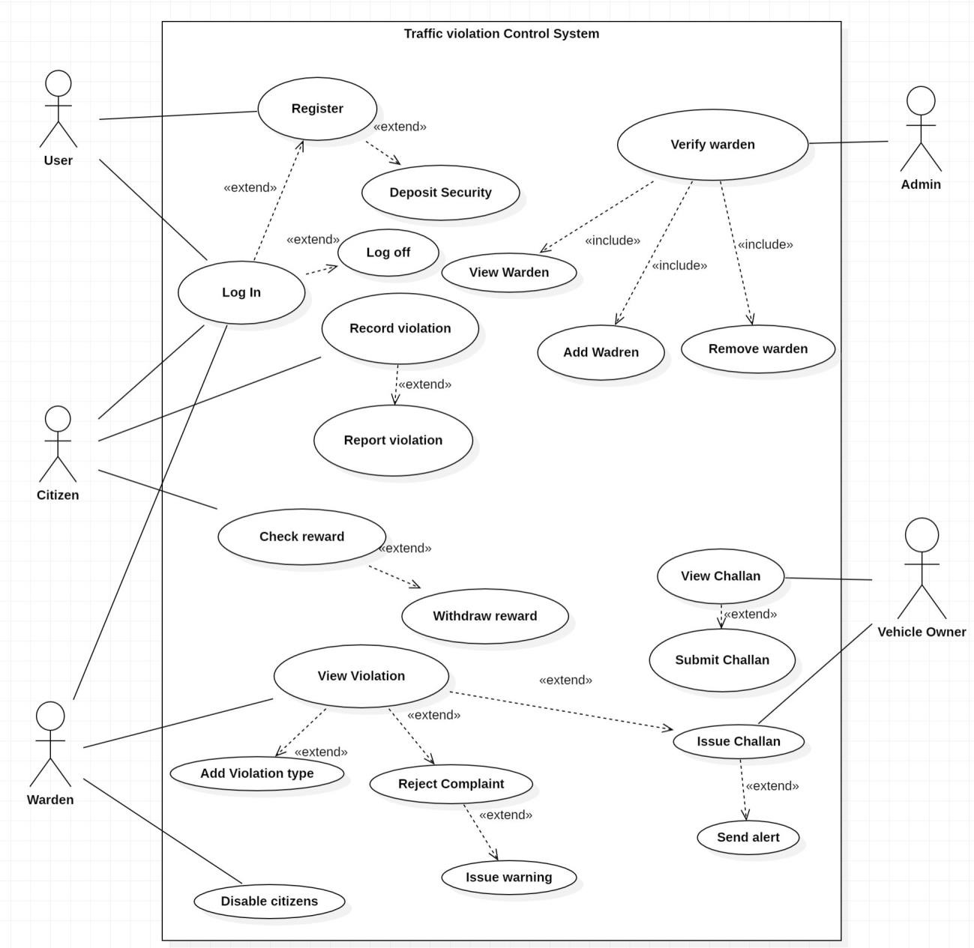

## Use Cases Distribution

|  |  |  |
| --- | --- | --- |
| S#. | Group Member | Assigned Use Cases |
| 1 | <Shah Rafi Alam Khattak>  <SP21-BSE-060> | UC 1 :Register  UC 2: Deposit Security  UC 3: Login |
| 2 | <Zakeen Khan>  <SP21-BSE-083> | UC 6: Issue Challan  UC 7: Send Alert  UC 8:Record violation |
| 3 | <Muhammad Shahan>  <SP21-BSE-081> | UC 9: View Violation  UC 10: Add Violation Type  UC 11: Reject Complaint  UC 12: Send Warning |
| 4 | <Usama Sajjad >  <SP21-BSE-049> | UC 14: View Challan  UC 15: Submit Challan  UC 16: Disable Citizen |
| 5 | <Hikmat Ullah>  <SP21-BSE-097> | UC 13: Check Reword  UC 14: Withdraw Reword  UC 5: Report Violation |
| 6 | <Shams ul Arifeen>  <SP21-BSE-076> | UC 17: Verify Warden  UC 18: View Warden  UC 19: Add Warden  UC 20: Remove Warden |

Brief Level Use Cases

Shah Rafi Alam Khattak (SP21-Bse-060)

#### Use Case: Register

The user wants to communicate with the system. The system asks for a first name, last name, email, password, confirm password, city, and the user enters their all the information. The system verifies the entered name and password and login the user into the system.

#### Use Case: Deposit Security

Security deposit is the amount that the administrator takes from the user as a security. If the user breaks or violates the terms of the agreement like the secondary user has reported a wrong video, then this is an alert to pay the challan. The admin collects the security in advance. So that in case of any misconception the user will lose his security.

#### Use Case: Log in

The user enters the correct information. Username and correct password with a good network connection.

Zakeen khan (SP21-BSE-083)

Use case

Issue Challan:

Warden: Warden will detect violations and then **view violations** if the violation is major then **issue a challan** and **send an alert** to the vehicle owner and if the violation is minor, then **reject the complaint** and **issue a warning.**

Vehicle Owner: when the vehicle owner violet any rule then he will pay a challan when the challan is issued by the traffic warden then the vehicle owner gets an alert message and receive challan according to his volition. After that vehicle owner **views Challan** and **submits the challan** after receiving the violation challan from the warden.

Record Violation

Use case

Citizen:

The citizen Detects the violation in traffic record it and then reports its recorded video of violation and upload to the system.

Send Alert

Use case

The warden will Send you alert notification to the violator for his violation with penalty amount after add his details in the system.

Muhammad Shahan (SP21-BSE-081)

#### Use Case:

#### View Violation:

In this use case, the warden will review the video which is being reported by the citizen. The warden is given the authority to do the following things (use cases).

*Add Violation type:*

When the warden receives the videos. Then the warden reviews the video that if it is a major violation or not. If it is a major violation then the warden assigns it a violation which that driver has broken. If it is not a major violation then the warden does the following.

*Reject complaint:*

If the video does not qualify to be a major violation. Then the warden will reject the video and do the following.

*Send warning:*

After the rejection of the video, the warden would send a warning to the citizen for sending a false video.

| Usama Sajjad (Sp21-Bse-049)  Use case **Disable Citizen** Warden:  Warden check the recorded video from their system weather the person uploaded video is authentic or not. If he approved the video then the car owner get challan against his traffic violation and the person who recorded video he will get the reward.  Remove Citizen:  If the recorded video is not related to the any violation then the warden has authority to disapprove the video and remove the citizen who uploaded the unauthentic video. **Use Case: View Challan** Citizen:  The person who get the challan against the traffic violation will view their challan through message alert. The warden send the alert through their system that he violate the traffic rules. After viewing their challan he will choice to pay their challan through our app or from traffic office. **Use Case: Submit Challan** Citizen:  The person who get the challan against the traffic violation will submit their challan through our app or in traffic office. After submitting challan the person who send the valid video will get some percentage of the challan in reward.  Hikmat Ullah (Sp21-Bse-097)  Use case  SHAMS UL Arifeen (SP21-BSE-076)  Use Case: Fully Addressed Used caseShah Rafi Alam Khattak (Sp21-Bse-060)Use Case: Register **Scope**: Register  **Level**: User, citizen and warden Goal  **Primary** **Actor**: User, citizen and warden  **Stakeholders and Interests**:  **Register:** Will register themself first to interact with the system for their kind of information about challans.   * **Users:** Want to register an account in the Traffic management system. * **Citizen:** Want to register an account in the Traffic management system. * **Warden:** Register User and Monitoring System in the Traffic Management System.   **Preconditions**:   * The System is running correctly. * The system has a stable internet connection.   **Success Guarantee** (or Postconditions):   * The user decides to register in the system. * Users starts the registration process. * The user gets registered.   **Main Success Scenario (or Basic Flow):**   1. User wants to open the Traffic management system to register an account. 2. System redirects him to the registration page. 3. System asks him to provide the details. 4. The user enters his first name, last name, email, and password. 5. System then checks if the account is already registered or not. 6. The account is registered the system asks to provide new information. 7. The account is not already registered then the system registers the account. 8. System then takes the user to its dashboard where he can access his own profile.   **Extensions (or Alternative Flows):**  No alternative flow Is present for register section.  **Special Requirements:**   * Username * Password * Email * City   **Technology and Data Variations List**:   * Smart Phone * Laptop * Computer * Internet.   **Open Issues:**   * If the person want to register provide false information.  **Gui:**Graphical user interface, application  Description automatically generatedShah Rafi Alam Khattak (Sp21-Bse-060)Use Case: Deposit Security **Scope**: Deposit Security  **Level**: User and citizen Goal  **Primary** **Actor**: User and citizen  **Stakeholders and Interests**:  **Sign up:** The Citizen will deposit its security for the security reason.   * The Security will be detected from Citizen if he didn’t pay its penalty.   **Preconditions**:   * The user has registered in the system. * The user must have a financial account.   **Success Guarantee** (or Postconditions):   * The user has deposited the security to the system. * The system has accepted the deposit request of the user.   **Main Success Scenario (or Basic Flow):**   * The user will click on the deposit security. * The system will ask for the deposit security options. * The user will select the option. * The user will deposit the security. * The system will give a confirmation notification to the user.   **Extensions (or Alternative Flows):**  No alternative flow to the registration if he doesn’t pay the security  **Special Requirements:**   * Register * Security Challan   **Technology and Data Variations List**:   * Smart Phone * Laptop * Computer * Internet * Financial account   **Open Issues:**   * The user is poor.  Gui:Graphical user interface, application  Description automatically generatedShah Rafi Alam Khattak (Sp21-Bse-060)Use Case: Log In **Scope**: Log in  **Level**: User citizen and warden Goal  **Primary** **Actor**: User citizen and warden  **Stakeholders and Interests**:  User firstly register yourself then the second step is that user enter email and password to log in the traffic management system.  **Preconditions**:   * User are not log in before register.   **Success Guarantee** (or Postconditions):   * The user gets log in. * The system redirects the user to dashboard.   **Main Success Scenario (or Basic Flow):**   * Users gets registered in the system. * The user login to the system. * The user gets log in to the account/system.   **Extensions (or Alternative Flows):**  No alternative flow Is present for login section  **Special Requirements:**   * Email * Password   **Technology and Data Variations List**:   * Smart Phone * Laptop * Computer   **Open Issues:**   * If the person want to log in and provides false information.  **Gui:**Graphical user interface, application  Description automatically generated**Gui Dashboard:**Zakeen khan (SP21-BSE-083)  | Use Case: Issued Challan | | --- | | **Scope**: Issue Challan  **Level**: Warden’s goal  **Primary** **Actor**: warden, Vehicle Owner  **Stakeholders and Interests**:  Warden: warden is the man in charge to control traffic flow and look for traffic violators and for those who violate traffic rules detect the violator’s vehicle and issue a challan to the vehicle according to their violation the violator receives a challan from a traffic warden.  **Preconditions**: Need to log in. |   **Success Guarantee**: The issue challan will be exactly according to the violation and the vehicle owner will not negotiate with the warden for his violation.  **Main Success Scenario (or Basic Flow):**   * Warden will log in to the system. * Warden will issue the challan. * Warden will send an alert message to the violator. * Violators or receive challan from the warden. * Violator will receive an alert message. * Violator will submit his challan.   **Extensions (or Alternative Flows):**  No alternative flow is present for the login section.  **Special Requirements:**   * Warden Name * Password   **Technology and Data Variations List**:   * Challan printer Device.   **Open Issues:**   * The warden detects any false Violation? * The false challan is issued according to the violation. * False alert is sent.   Major violation is rejected  **GUI**   Use Case: Record violation  | **Scope**: record violation  **Level**: Citizen Goal  **Primary** **Actor**: Citizen  **Stakeholders and Interests**:   * **Citizen:** Want to register an account in the Traffic management system?   The violation of traffic is recorded by citizens and submitted to the system  **Preconditions**:   * Users must sign up and log in to the system. | | --- |   **Success Guarantee** (or Postconditions):   * The system will look for the violation if the violation is major then the system will issue a challan.   **Main Success Scenario (or Basic Flow):**   1. The traffic flow will be according to rules if there is no warden. 2. The violator will receive a challan if the warden is not present.   **Extensions (or Alternative Flows):**  No alternative flow Is present for the login section  **Special Requirements:**   * Username * Password   **Technology and Data Variations List**:   * Smart Phone * Camera   **Open Issues:**   * The citizen reports false violations.  Use Case: Send Alert  | **Scope**: Send Alert Massage to the Violator.  **Level**: Warden Goal  **Primary** **Actor**: Warden  **Stakeholders and Interests**:   * **Warden:** Want to Send the alert massage to the violator.   The warden will send the massage to the violator about his violation details .   * **Preconditions**: * Users must sign up and log in to the system. * Warden must detect some violation. | | --- |   **Success Guarantee** (or Postconditions):   * When the challan is issued the alert massage must be send to the violator.   **Main Success Scenario (or Basic Flow):**   * The violator will receive a challan if the warden is not present. * The violator is received details about his violation.   **Extensions (or Alternative Flows):**  No alternate way is present without sending alert after issued challan.  **Special Requirements:**   * Violator phone number * Violation   **Technology and Data Variations List**:   * Smart Phone * Challan Print Device   **Open Issues:**   * The citizen reports false violations alert.   **GUI** |
| --- | --- | --- | --- | --- |

| Muhammad Shahan (SP21-BSE-081) Use Case UC1: View Violation |
| --- |
| **Scope**: Review violation  **Level**: Warden’s duty  **Primary** **Actor**: Warden  **Stakeholders and Interests**:  -Warden: Wants to review the violation video received and is in search of an authentic video so that he can issue a challan or reject the video.  **Preconditions**: The video is uploaded.  **Success Guarantee** (or Post conditions): Video is uploaded by the citizen. The video is reported. The warden reviews the video.  **Main Success Scenario (or Basic Flow):**   1. The citizen uploads a video. 2. The citizen reports the video. 3. The warden receives the video. 4. The warden reviews the video. 5. The video indicates a major violation. 6. The warden approves the video. 7. The warden issues a challan (Fine) to the driver.   **Extensions (or Alternative Flows):**  There is no extension or alternative flow of this use case.  **Special Requirements:**   * The video should be uploaded by the citizen. * The video should be reported. * The video should be authentic for being reported as a violation.   **Technology and Data Variations List**:   * Smartphones * Laptops * Personal computers * internet   **Open Issues:**   * What are the limits for a video to be approved by the warden? * What are the rules of violation?   Use Case UC2: Add Violation type  **Scope**: Add type  **Level**: Warden’s duty  **Primary** **Actor**: Warden  **Stakeholders and Interests**:  -Warden: Wants to add violation type of the video received as a violation. To refer the user about the violation he has done.  **Preconditions**: The video is uploaded.  **Success Guarantee** (or Post conditions): Video is uploaded by the citizen. The video is reported. The warden reviews the video. The video indicates a major violation. The warden declares the type of violation.  **Main Success Scenario (or Basic Flow):**   1. The citizen uploads a video. 2. The citizen reports the video. 3. The warden receives the video. 4. The warden reviews the video. 5. The video indicates a major violation. 6. The warden declares a violation type of the video.   **Extensions (or Alternative Flows):**  There is no extension or alternative flow of this use case.  **Special Requirements:**   * The video should be uploaded by the citizen. * The video should be reported. * The video should be authentic for being reported as a violation.   **Technology and Data Variations List**:   * Smartphones * Laptops * Personal computers * internet   **Open Issues:**   * What are the limits for a video to be approved by the warden? * What are the rules of violation?   Use Case UC3: Reject complaint  **Scope**: Complaint authentication  **Level**: Warden’s duty  **Primary** **Actor**: Warden  **Stakeholders and Interests**:  -Warden: Wants to review the violation video sent by the citizen and authenticate the video whether to reject or accept the video as a violation.  **Preconditions**: The video is uploaded and being compliant.  **Success Guarantee** (or Post conditions): Video is uploaded by the citizen. The video is reported. The warden reviews the video. The warden rejects the complaint.  **Main Success Scenario (or Basic Flow):**   1. The citizen uploads a video. 2. The citizen reports the video. 3. The warden receives the video. 4. The warden reviews the video. 5. The warden rejects the video.   **Extensions (or Alternative Flows):**  There is no extension or alternative flow of this use case.  **Special Requirements:**   * The video should be uploaded by the citizen. * The video should be reported. * The video should be authentic for being reported as a violation.   **Technology and Data Variations List**:   * Smartphones * Laptops * Personal computers * internet   **Open Issues:**   * What are the limits for a video to be approved by the warden? * What are the rules of violation?   Use Case UC4: Issue warning  **Scope**: Send warning notification.  **Level**: Warden’s duty  **Primary** **Actor**: Warden  **Stakeholders and Interests**:  -Warden: Wants to send a warning notification as a warning to the citizen for uploading a false video in which the warden was unable to find a traffic violation and rejected the video to be reported as a violation.  **Preconditions**: The video is uploaded and compliant and the warden did not find the video as a traffic violation. The warden them sends a warning to the citizen.  **Success Guarantee** (or Post conditions): Video is uploaded by the citizen. The video is reported. The warden reviews the video. The warden rejects the complaint and sends a warning notification to the user.  **Main Success Scenario (or Basic Flow):**   1. The citizen uploads a video. 2. The citizen reports the video. 3. The warden receives the video. 4. The warden reviews the video. 5. The warden rejects the video. 6. The warden sends a warning notification to the citizen.   **Extensions (or Alternative Flows):**  There is no extension or alternative flow of this use case.  **Special Requirements:**   * The video should be uploaded by the citizen. * The video should be reported. * The video should be authentic for being reported as a violation.   **Technology and Data Variations List**:   * Smartphones * Laptops * Personal computers * internet   **Open Issues:**   * What are the limits for a video to be approved by the warden? * What are the rules of violation? |

GUI:

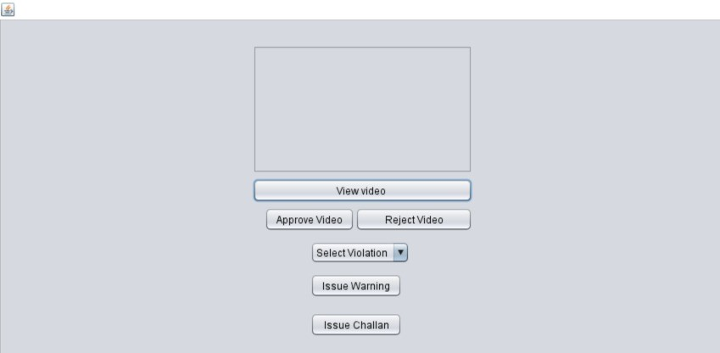

#### Usama Sajjad (SP21-BSE-049)

| Use Case: Disable Citizen |
| --- |
| **Scope**: Review violation  **Level**: Warden’s duty  **Primary** **Actor**: Warden  **Stakeholders and Interests**:  -Warden: Wants to review the violation video received and is in search of an authentic video so that he can issue a challan or remove the citizen which has not uploaded authentic video.  **Preconditions:** The video is uploaded.  **Success Guarantee** (or Post conditions): Video is uploaded by the citizen. The video is reported. The warden reviews the video. The video indicates a violation. The warden approves it. The warden issues a challan to the driver or remove the citizen. |

**Main Success Scenario (or Basic Flow):**

* The warden view the video.
* The video not indicate the violation.
* The warden check the warning status.
* The warden remove the citizen.

**Extensions (or Alternative Flows):**

There is no extension or alternative flow of this use case.

**Special Requirements:**

* The video should be uploaded by the citizen.
* The video should be reported.
* The video should be authentic for being reported as a violation.

**Technology and Data Variations List**:

* Smartphones
* Laptops
* Personal computers
* internet

**Open Issues:**

* What are the limits to remove the citizen by warden?
* What are the rules of violation?

**GUI**

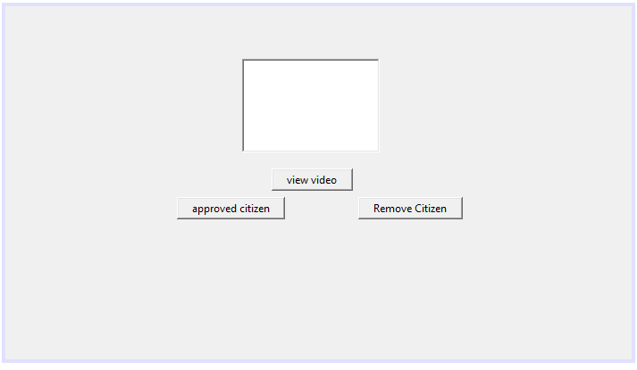

| Use Case: View Challan |
| --- |
| **Scope**: View Challan  **Level**: Vehicle Owner  **Primary** **Actor**: Vehicle Owner  **Stakeholders and Interests**:  -Vehicle Owner: Vehicle owner will see the challan and the type of challan that was issued for his traffic violation.  **Preconditions**: The Challan is issued. |

**Success Guarantee** (or Post conditions): The challan is issued by the warden. The video is reported. The warden reviews the video. The video indicates a violation. The warden approves it. The citizen will have to pay the challan.

**Main Success Scenario (or Basic Flow):**

* The Vehicle owner receives a notification.
* The Vehicle owner receives the challan.
* The vehicle owner review the challan.

**Extensions (or Alternative Flows):**

The Vehicle owner will get the physical challan by the traffic warden on the road.

**Special Requirements:**

* The challan should be uploaded by the warden.
* The challan should be visible on the app.
* The challan should be authentic for being reported as a violation.

**Technology and Data Variations List**:

* Smartphones
* Laptops
* Personal computers
* Internet

**GUI**

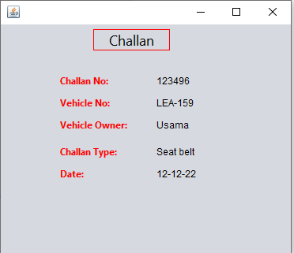

| **Use Case: Submit Challan** |
| --- |
| **Scope**: Challan submission  **Level**: Vehicle Owner  **Primary** **Actor**: Vehicle Owner  **Stakeholders and Interests**:  -Vehicle Owner: Vehicle owner will see the challan and the type of challan that was issued for his traffic violation. He will submit the challan by using our app or in the traffic office.  **Preconditions**: The Challan is issued. |

**Success Guarantee** (or Post conditions): The challan is issued by the warden. The vehicle owner will review the challan. The vehicle owner will submit the challan.

**Main Success Scenario (or Basic Flow):**

* The Vehicle owner receives a notification.
* The Vehicle owner receives the challan.
* The vehicle owner review the challan.
* The vehicle owner will submit the challan.

**Extensions (or Alternative Flows):**

The Vehicle owner will submit the challan physically in the traffic office.

**Special Requirements:**

* The challan should be uploaded on the app.
* The challan should be visible on the app.
* The challan should be properly submitted by the user.

**Technology and Data Variations List**:

* Smartphones
* Laptops
* Personal computers
* Internet

#### Hikmat Ullah (SP21-BSE-097)

| Use Case: |
| --- |

#### Shams ul Arifeen (SP21-BSE-076)

| Use Case: |
| --- |

#### Chapter 3 System Sequence Diagram

#### Shah Rafi Alam Khattak (SP21-BSE-060)

**SSD:**

**Register:**

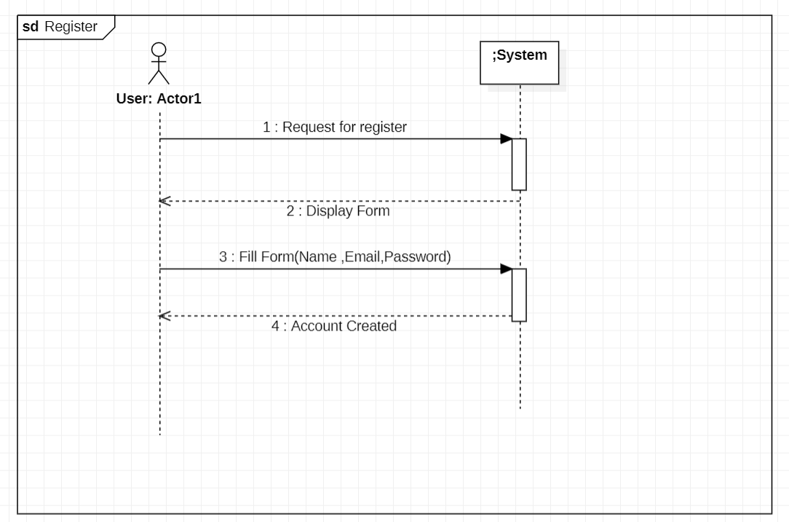

**Deposit Security:**

**Log In:**

#### Zakeen khan (SP21-BSE-083)

SSD: Issue Challan

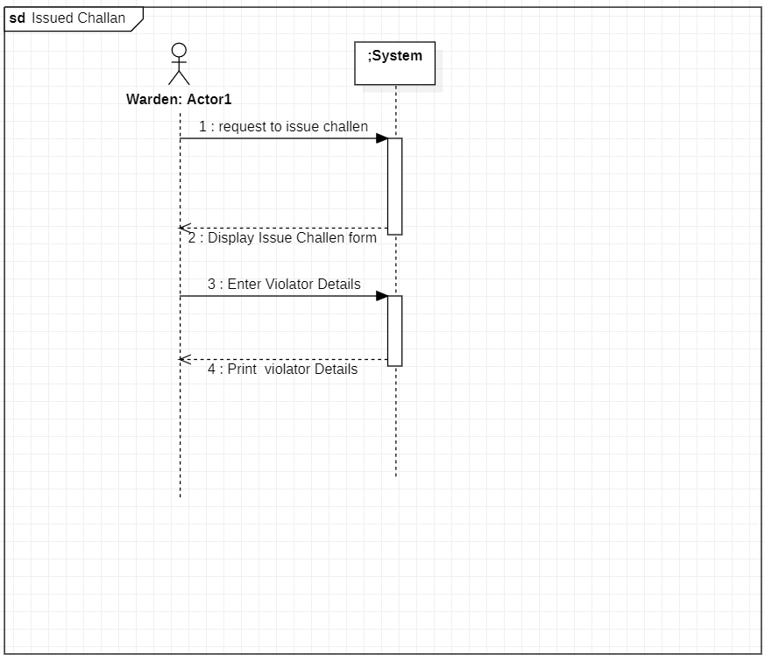

SSD: Record Violation

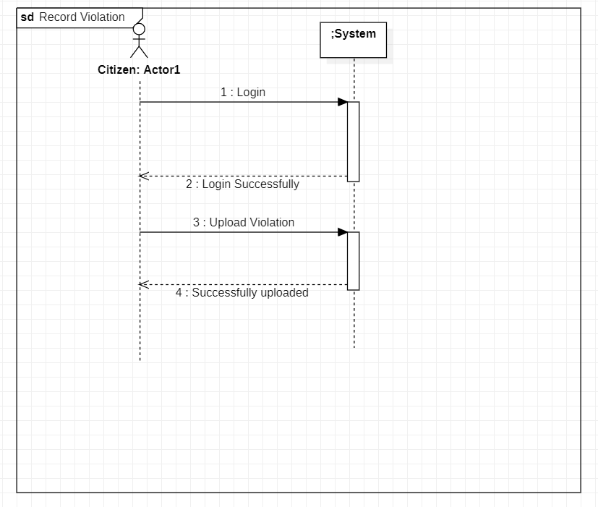

SSD: Send Alert

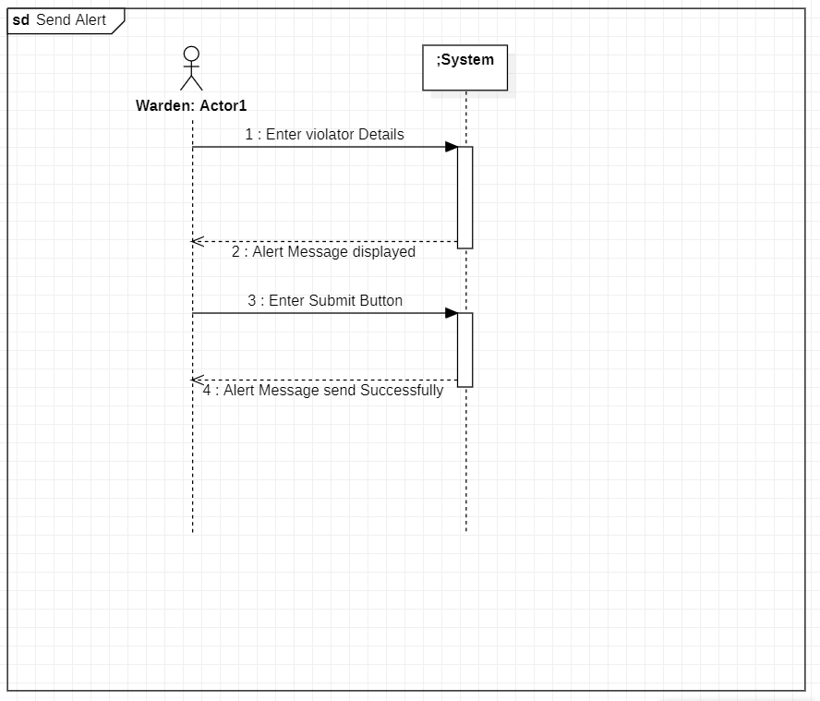

#### Muhammad Shahan (SP21-BSE-081)

SSD:

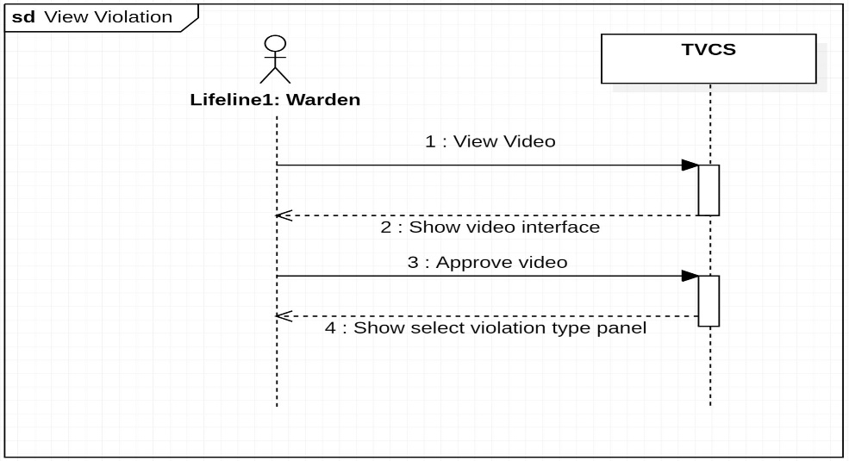

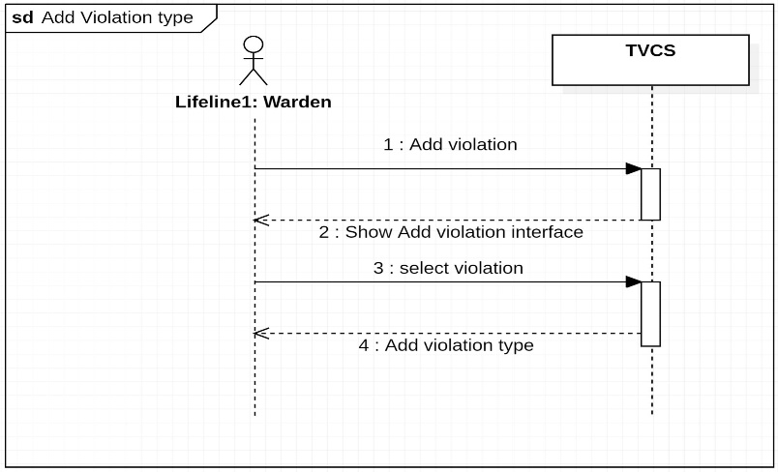

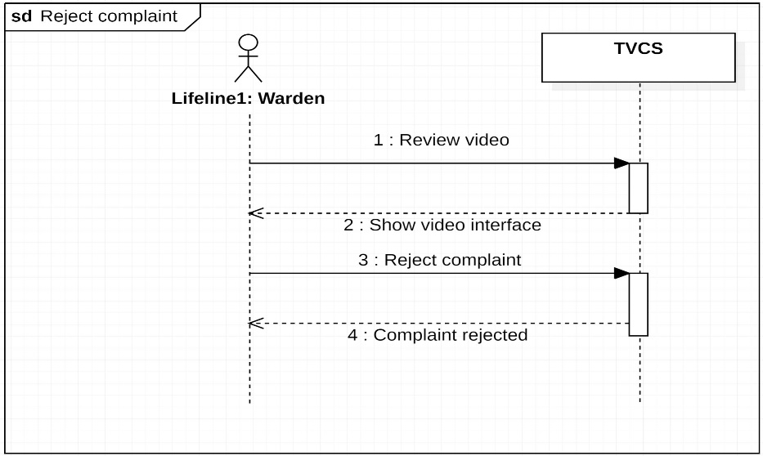

#### 

#### Usama Sajjad (SP21-BSE-049)

SSD: Disable Citizen

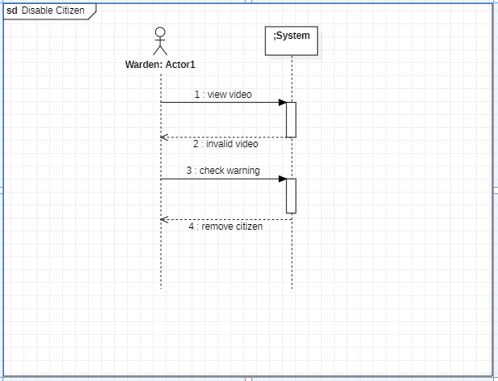

SSD: View Challan:

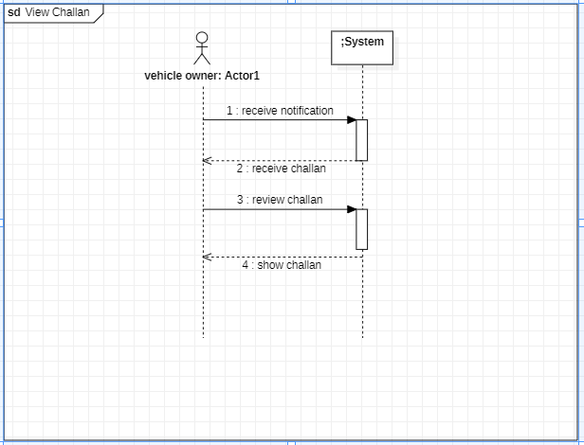

SSD: Submit challan:

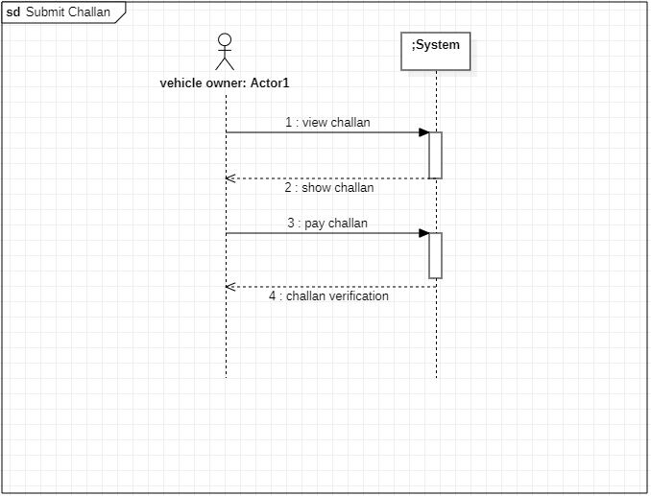

#### Hikmat Ullah (SP21-BSE-097)

SSD

#### Shams Ul Arifeen (SP21-BSE-076)

SSD

**Chapter 4 Domain Model**

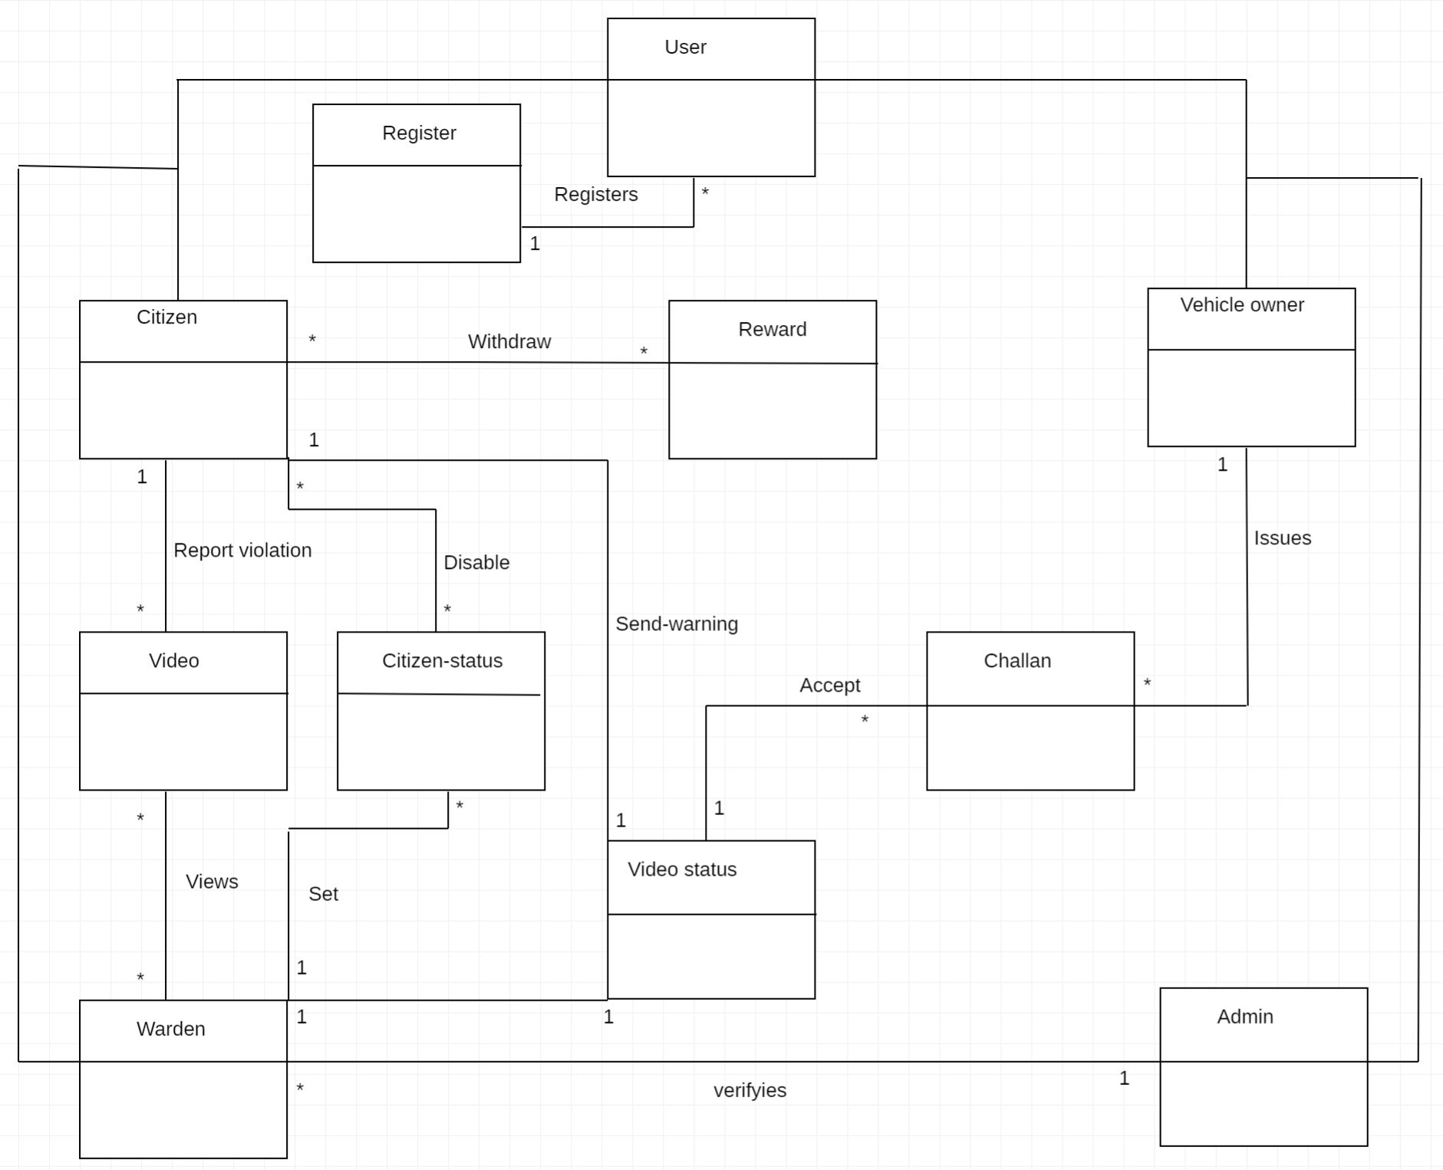

Chapter 5 Operation Contracts

Usama Sajjad (Sp21-Bse-049)

## Disable Citizen:

|  |  |
| --- | --- |
| Operation: | DeleteCitizen (userId,UserName). |
| Cross-Reference: | Use Cases: Disable Citizen |
| Pre-Condition: | User is already registered in the system and his warnings is 3. |
| Post-Condition: | * DeleteCitizen Object was created * Record of the citizen was removed from the database. * The citizen violation video was removed. |

## View Challan:

|  |  |
| --- | --- |
| Operation: | ViewChallan (userId,UserName,UserChallanNo). |
| Cross-Reference: | Use Cases: View Challan |
| Pre-Condition: | User has break the traffic rule and he gets notification about violation. |
| Post-Condition: | * View Challan Object was created * The video was shown to the user. * The challan was generated. |

## Submitt Challan:

|  |  |
| --- | --- |
| Operation: | SubmitChallan (UserName,ChallanNo,ticketPrice). |
| Cross-Reference: | Use Cases: Submit Challan |
| Pre-Condition: | The challan is given to the vehicle owner. |
| Post-Condition: | * Submit challan object was created. * The payment method was shown. * The user was selected the challan payment method. * The user payed the challan. |

Muhammad Shahan (SP21-BSE-081)

|  |  |
| --- | --- |
| **Contact US1: View Violation** | |
| Operation | View Violation(Video path) |
| Cross references | View video |
| Precondition | The citizen has uploaded and reported the video. |
| Postcondition | * A ViewViolation instance was created. * This instance was associated with the video display. * The video was displayed. |

|  |  |
| --- | --- |
| **Contact US2: Add violation type** | |
| Operation | Add Violation(Violation type) |
| Cross references | Add violation type. |
| Precondition | The warden has viewed the video and declared it a violation. |
| Postcondition | * A ViolationType instance was created. * This instance was associated with Adding a violation type. * The violation type was added. |

|  |  |
| --- | --- |
| **Contact US3: Reject complaint** | |
| Operation | Reject complaint. |
| Cross references | Reject violation video. |
| Precondition | The warden viewed the video and did not find it a violation. |
| Postcondition | * A RejectComplaint instance was created. * This instance was associated with the Complaint. * The Complaint was rejected. |

|  |  |
| --- | --- |
| **Contact US4: Send warning** | |
| Operation | Send warning. |
| Cross references | Send warning notification. |
| Precondition | The warden rejected the video. |
| Postcondition | * A SendWarning instance was created. * This instance was associated with the notification sent. * The warning notification was sent. |

Zakeen Khan (SP21-BSE-083)

|  |  |
| --- | --- |
| **Contact US1: Issue Challan** | |
| **Operation** | Challan (Challan file) |
| **Cross references** | Send challan |
| **Precondition** | The video must be approved by the warden. |
| **Postcondition** | * An Issue Challan instance was created. * This instance was associated with sending challan forms. * The user has received the challan. |

|  |  |
| --- | --- |
| **Contact US2: Record Violation** | |
| Operation | Record video(video) |
| Cross references | Record violation video |
| Precondition | The citizen has a camera device to record the video. |
| Postcondition | * A Record Violation instance was created. * This instance was associated with recording a violation video. * The violation video was recorded was added. |

|  |  |
| --- | --- |
| **Contact US3: Send alert** | |
| **Operation** | Send Alert (Alert notification) |
| **Cross references** | Send alert notification. |
| **Precondition** | The challan was issued by the warden. |
| **Postcondition** | * A Send Alert instance was created. * This instance was associated with sending challan notifications. * The alert was received by the vehicle owner. |

Shah Rafi Alam Khattak (SP21-BSE-060)

|  |  |
| --- | --- |
| **Contact US1: Register** | |
| Operation | Register (Username, Password, Email) |
| Cross references | Registration Process |
| Precondition | * Users are not registered. * The System is running correctly. * The system has a stable internet connection. |
| Postcondition | * User starts the registration process. * A Registration instance was created. * This instance was associated with Adding to register user. * The user was register. |

|  |  |
| --- | --- |
| **Contact US3: Deposit Security** | |
| Operation | Deposit Security |
| Cross references | Deposit Security |
| Precondition | * The user has fill the register form. |
| Postcondition | * The user has deposited the security to the system. * The system has accepted the deposit request of the user. |

|  |  |
| --- | --- |
| **Contact US2: Log In** | |
| Operation | Log In (Username, Password) |
| Cross references | Log In Process. |
| Precondition | The User is already registered, and the login form is displayed. |
| Postcondition | * A new user was searched in the database. if the user entry is correct then login the system and displayed the dashboard. |

**Chapter 6 Logical Architecture:**

